

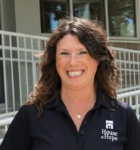
Dusky Steele
House of Hope Development Director
:Building Futures With Women

November 24, 2025
Diamond Event Center South
5307 Caraway Lane, Cedar Falls
Gather at 5:00, program at 5:30, dinner at 6:15

A selection of wines will be available ($7/glass) during the 5:00-5:30 social time.

The dinner menu begins with a house salad (spring mix with cranberries and almonds and raspberry vinaigrette dressing) and dinner roll and butter. The entrée is pork loin with garlic mashed potatoes and green beans. (The vegetarian entrée is a Portobello mushroom pizza with toppings
of various veggies such as peppers, onions, and olives).
Dessert is a pumpkin bar.

To reserve a dinner ($20 at the door), RSVP to Mary Ellen Beckman at AAUW.CFW.RSVP@gmail.com or 319-269-1893 (and specify vegetarian or meat option) no later than Sunday, November 16. Please respect this RSVP deadline. When you RSVP, you will receive a verification reply that confirms you have been added for a meal. If you do not receive a verification reply, contact Mary Ellen—before November 16!.

